**CHURN PREDICTION PROJECT REPORT**

# **1. Introduction to Churn Prediction**

Churn Prediction involves identifying which customers are likely to stop using a company’s products or services in the near future. This is crucial in subscription-based businesses, telecom, e-commerce, and other industries where customer retention drives profitability.

# **2. Purpose of Churn Prediction**

The main goal of churn prediction is to:

* Proactively retain at-risk customers by identifying them early.
* Increase customer satisfaction by understanding pain points.
* Improve overall customer lifetime value by reducing churn rates.

# **3. Dataset Overview**

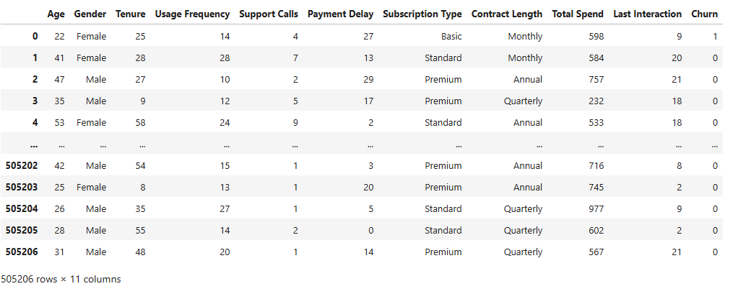

**Source:**

* customer_churn_dataset-training-master.csv
* customer_churn_dataset-testing-master.csv  
  (Downloaded from Kaggle)

**Features (12 columns):**

| **Feature** | **Description** |
| --- | --- |
| CustomerID | Unique identifier for each customer |
| Age | Age of the customer |
| Gender | Gender of the customer |
| Tenure | Months the customer has used the service |
| Usage Frequency | Service usage in the last month |
| Support Calls | Calls made to customer support last month |
| Payment Delay | Days the customer delayed payment last month |
| Subscription Type | Type of subscription plan |
| Contract Length | Duration of customer's contract |
| Total Spend | Total amount spent on products/services |
| Last Interaction | Days since the last interaction |
| Churn | Target variable (1 = churned, 0 = not churned) |

# **4. Key Features for the Churn Prediction Project Dataset**

The following features were found to be most significant for predicting churn:

1. **Age** – Older customers may churn less frequently.
2. **Support Calls** – Frequent support calls could signal dissatisfaction.
3. **Payment Delay** – Delays in payment may indicate churn risk.
4. **Last Interaction** – Long inactivity gaps suggest disengagement.

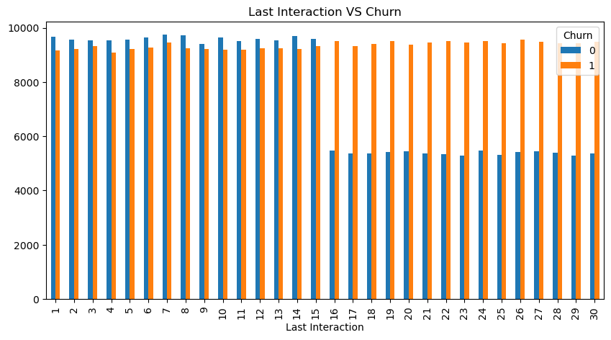

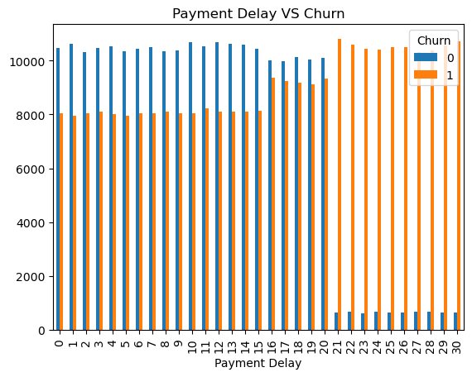

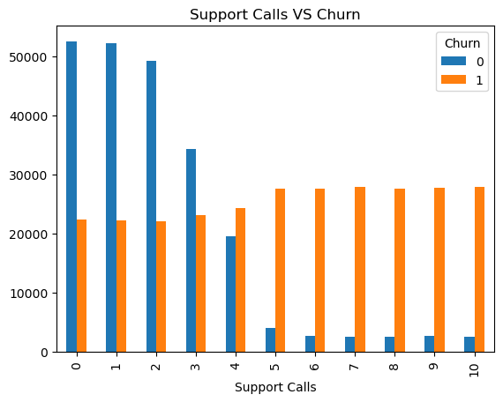

# **5. Observed Churn Factors**

Based on exploratory analysis:

* **Customer Support Issues**: More than 3 support calls in a month often led to churn.
* **Transaction Delays**: Customers experiencing delays of over 15 days in service confirmation are more likely to churn.
* **Low Engagement**: Customers who haven’t been engaged for over 14 days tend to churn.

# **6. Churn Reduction Recommendations**

To minimize churn:

1. **Improve Customer Service**
   * Faster response times and helpful resolutions.
2. **Address Payment and Delivery Delays**
   * Streamline operations to ensure timely service.
3. **Enhance Customer Engagement**
   * Regular touchpoints, personalized communications, and loyalty incentives.

# **7. Model Performance**

**Model Accuracy: 85.9%**

| **Metric** | **Class 0 (Not Churned)** | **Class 1 (Churned)** |
| --- | --- | --- |
| Precision | 0.84 | 0.88 |
| Recall | 0.85 | 0.87 |
| F1-score | 0.84 | 0.87 |

**Overall KNN Classifier Model Evaluation:**

* **Macro Avg F1-Score**: 0.86
* **Support Size**: 101,042 customers

This indicates a robust model with balanced performance across both churn and non-churn classes.

# **8. Model Benefits**

The churn prediction model empowers the business to:

* Identify at-risk customers and intervene early.
* Optimize customer retention strategies.
* Allocate marketing and customer service resources more effectively.

# **9. Model Enhancement Recommendations**

To further improve model performance:

* **Conduct deeper feature engineering** to uncover hidden churn signals.
* **Incorporate behavioral and feedback data** (e.g., survey results, NPS).
* **Apply ensemble methods** for better predictive accuracy.
* **A/B test retention campaigns** informed by model predictions.

# **10. Dashboard Overview**

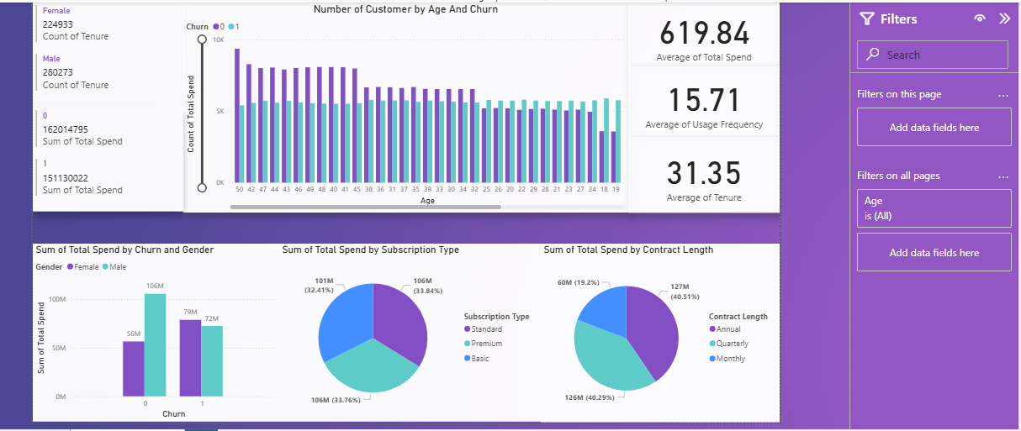

**Purpose:**

The dashboard visualizes key features and their relationships with churn to:

* Highlight impactful variables (like support calls, tenure, etc.).
* Track churn rates across different customer segments.

**Objective:**

To communicate the driving features behind churn and validate the model’s findings for stakeholders.

# **11. Conclusion**

This churn prediction project provides actionable insights into customer behavior. By understanding and mitigating churn risks through data, businesses can enhance retention, boost revenue, and improve overall customer experience.

Would you like me to help turn this into a formatted PDF or presentation deck?